Encoding ASCII into cf2022 colorForth tokens

2022 Apr 21 b

; ASCII / UTF8 support. If the first Shannon-Fano encoded letter is a 4 bit NULL,

; display the next 24 bits as three ASCII characters.

; $03e3c009 is displayed as ‘><’

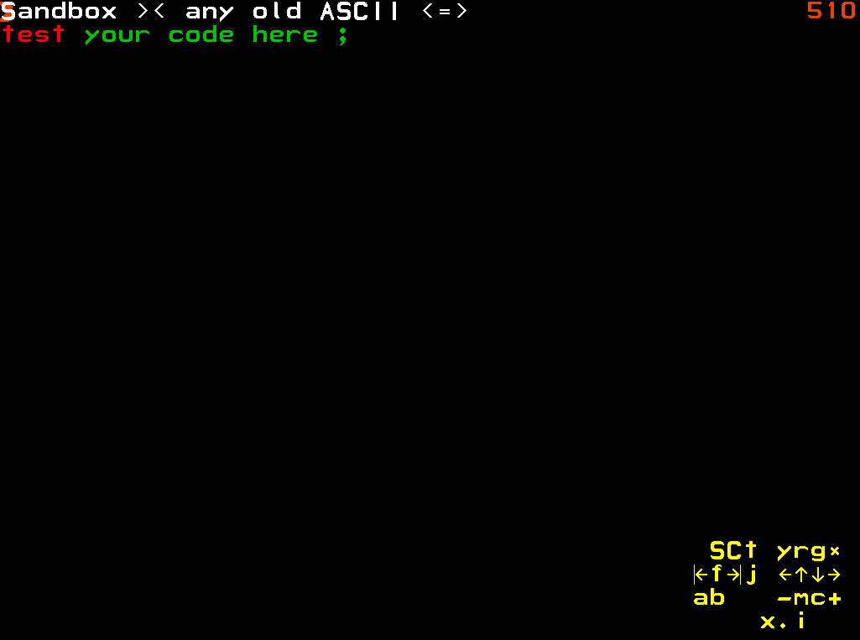

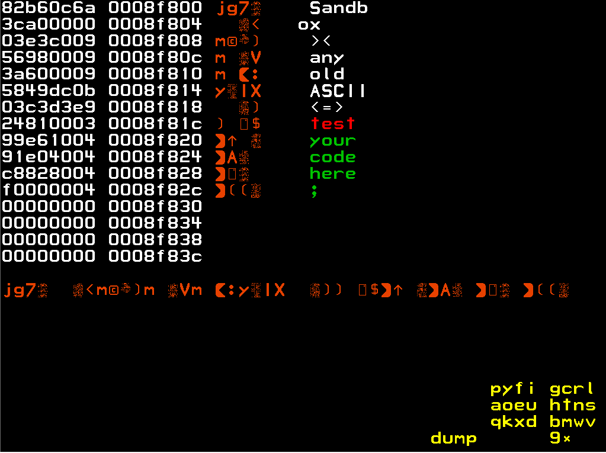

# Appendix A cf2022.nasm code

lowercase: ; display a white text word in normal lower-case letters

call white

showSF_EDI_: ; ( -- ) \ display a Shanon-Fano encoded token pointed to by edi in the current colour

_DUP_

mov _TOS_, [ ( edi * 4 ) - 0x04 ] ; fetch the next token – drops through to showShannonFano

showShannonFano: ; ( token -- ) \ display the Shannon-Fano encoded token on TOS

; ASCII / UTF8 support. If the first Shannon-Fano encoded letter is a 4 bit NULL,

; display the next 24 bits as three ASCII characters.

mov _SCRATCH_, _TOS_ ; save the token value

and _SCRATCH_, 0xF0000000

cmp _SCRATCH_, 0x00000000

jnz .forward

; display as three ASCII characters

mov _SCRATCH_, _TOS_

mov _TOS_, _SCRATCH_

shr _TOS_, 20

and _TOS_, 0x000000FF

jz .null_terminator

_DUP_

call emit_

mov _TOS_, _SCRATCH_

shr _TOS_, 12

and _TOS_, 0x000000FF

jz .null_terminator

_DUP_

call emit_

mov _TOS_, _SCRATCH_

shr _TOS_, 4

and _TOS_, 0x000000FF

jz .null_terminator

_DUP_

call emit_

; arrive here if an ASCII character is an ASCII NULL, or if all three have been emitted

.null_terminator:

call space_ ; display a space character at the end of the word

_DROP_

ret

.forward:

; display as Shannon-Fano encoded token name

and _TOS_, byte -0x10 ; and _TOS_, 0xFFFFFFF0 ignore token colour when displaying the letters

lowercasePrimitive: ; ( token -- ) \ display the given Shanon-Fano encoded word in the current colour

call unpack

jz lowercasePrimitiveEnd

call emitSF_

jmp lowercasePrimitive

lowercasePrimitiveEnd:

call space_

_DROP_

_DROP_

ret